DATE:25.08.2025

EXPERIMENT – 07 Create a Virtual Machine with 1 CPU, 2GB RAM and 15GB storage disk using a Type 2 Virtualization Software, using virtual box.

Aim:

To create a Virtual Machine with 1 CPU, 2GB RAM, and 15GB storage disk using a Type-2 Virtualization Software (VirtualBox).

Procedure:

1. Install VirtualBox:  
   Download and install Oracle VirtualBox on your host system.
2. Launch VirtualBox:  
   Open the VirtualBox Manager and click on New to create a new VM.
3. Name & OS Selection:
   * Enter VM name (e.g., *Ubuntu-VM* or *Windows-VM*).
   * Select Type: Windows/Linux.
   * Choose version (e.g., Ubuntu 64-bit or Windows 10).
4. Allocate Memory (RAM):
   * Assign 2048 MB (2GB) RAM.
5. CPU Configuration:
   * In Processor settings, allocate 1 CPU core.
6. Create Virtual Hard Disk:
   * Select Create a virtual hard disk now.
   * Choose format as VDI (VirtualBox Disk Image).
   * Allocate 15 GB storage (dynamically allocated or fixed size).
7. Mount OS ISO:
   * Go to VM Settings → Storage → Attach the OS ISO image (Linux/Windows).
8. Start the VM:
   * Boot the VM and proceed with OS installation.

Output:

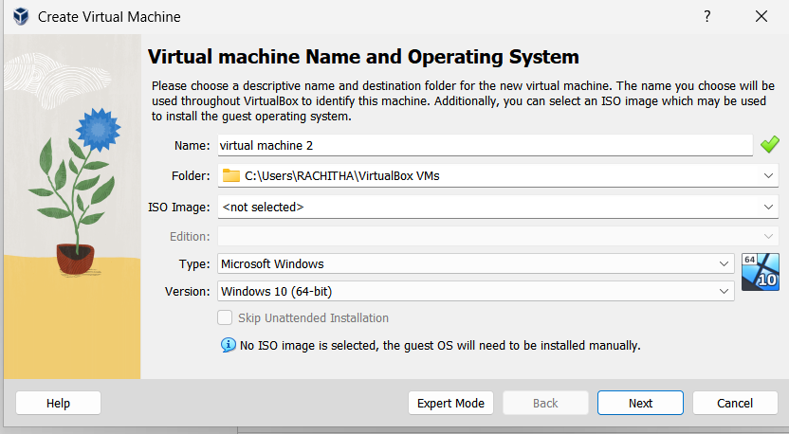

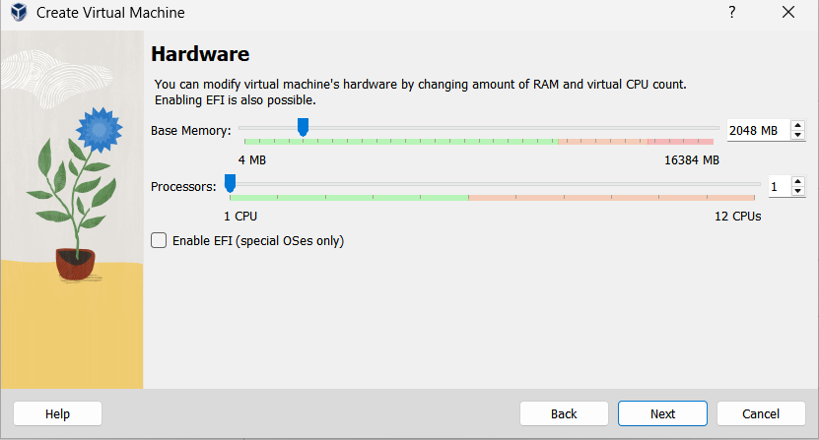

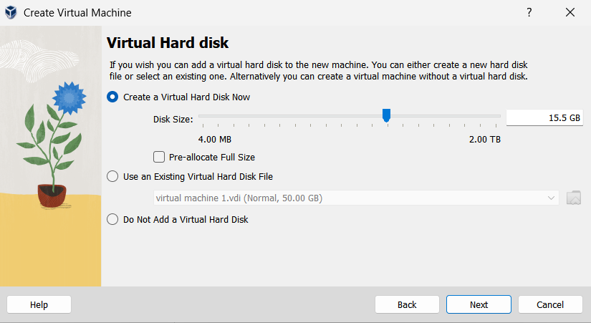

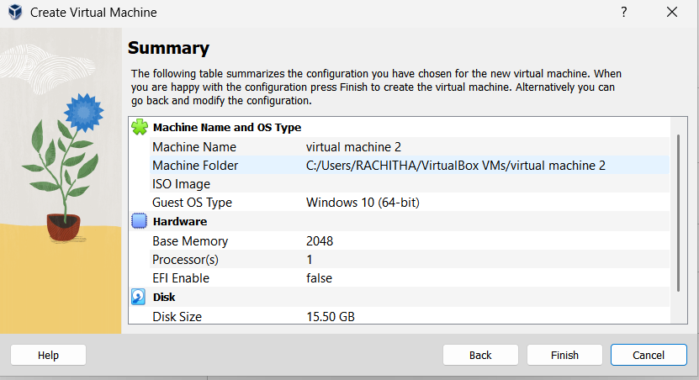

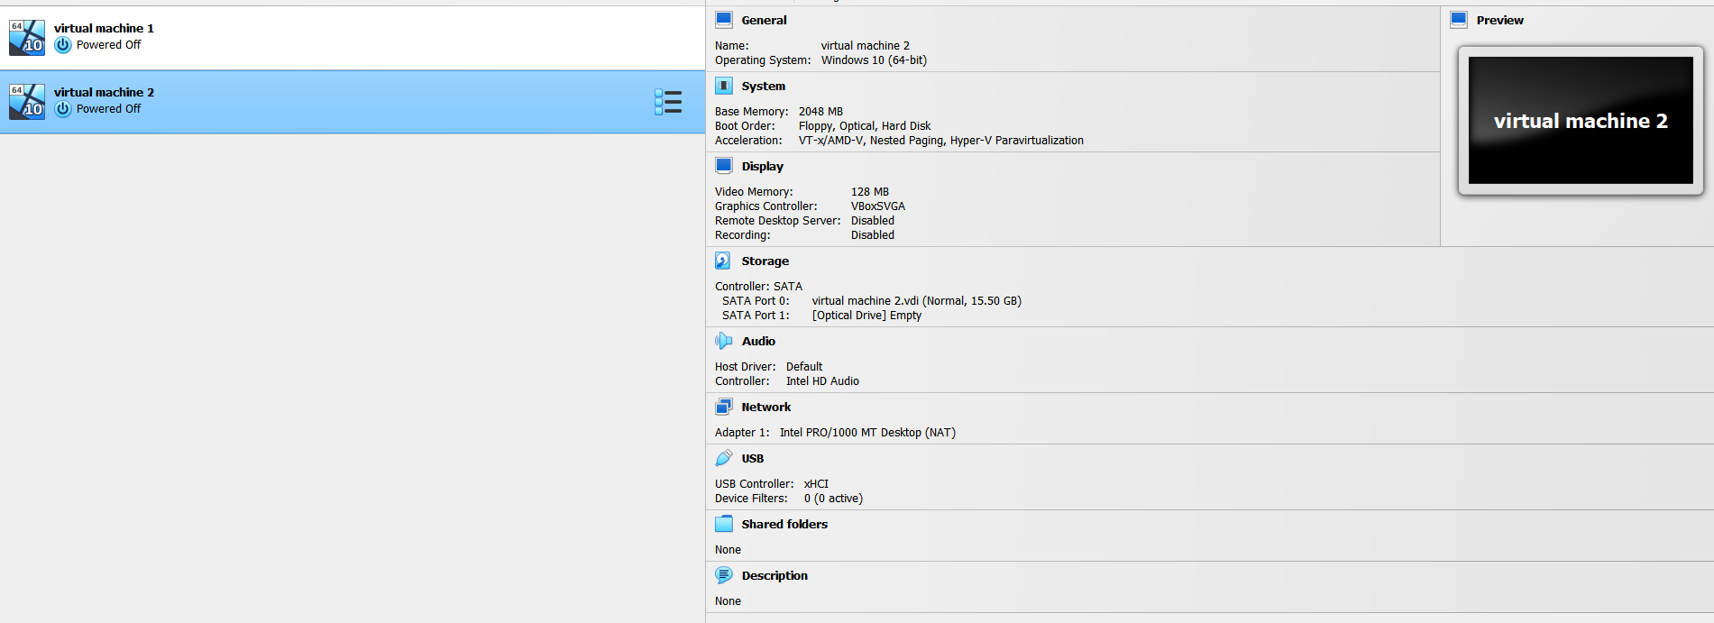

Result:

A Virtual Machine with 1 CPU, 2GB RAM, and 15GB storage disk was successfully created and configured using VirtualBox.